Retu Retket Outdoor Travels is at your service in the North-Eastern Tampere Region and is based on Vilppula, famous for its diverse fishing grounds. Trolling and spinning on lakes and rapids, ice-fishing and angling with a hook and line, with pike, zander, trout and perch as game species. Traditional fishing forms also available, such as torch fishing, ice-fishing burbot and longline fishing. Preparation of your catch for eating can be arranged. We offer boats, tackle and equipment for hire and various nature activities, such as canoeing, snowshoeing and hunting. We can also book your accommodation, catering and transportation services as required. Ask about our reasonable offers for service packages.

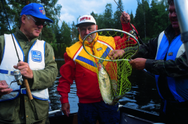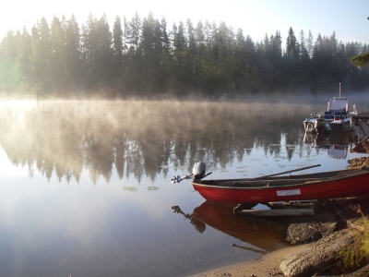

RETU RETKET Outdoor travels / Reima Aronen
Paavolantie 143. 35700 Vilppula
Tel. +358 400 757 997
www.returetket.fi
e-mail: retu@returetket.fi

